EXPERIMENT 4

AIM:
MATLAB Simulation of Superheterodyne Receiver for AM Communication System with Frequency Mixing and Filtering

SOFTWARE REQUIRED:
MATLAB Simulink

PROGRAM:
clc; clear; close all;
Fs=100000;
T=0:1/fs:0.02;
Fm=400; fc=5000; flo=6000;
M=cos(2*pi*fm*t);
C=cos(2*pi*fc*t);

% AM Signal
Am=(1+m).*c;

% Frequency Mixing
Lo=cos(2*pi*flo*t);
Mix=am.*lo;

% IF Filtering
[b,a]=butter(4,[800 1200]/(fs/2),’bandpass’);
IF=filter(b,a,mix);

% Demodulation
D=IF.*cos(2*pi*1000*t);
[b2,a2]=butter(4,600/(fs/2));
Rec=filter(b2,a2,d);
Rec=rec/max(abs(rec));

Subplot(5,1,1);
Plot(t,m); title(‘Message Signal’); grid on;

Subplot(5,1,2);
Plot(t,c); title(‘Carrier Signal’); grid on;

Subplot(5,1,3);
Plot(t,am); title(‘AM Signal’); grid on;

Subplot(5,1,4);
Plot(t,IF); title(‘Intermediate Frequency (IF) Signal’); grid on;

Subplot(5,1,5);
Plot(t,rec); title(‘Recovered Signal’); grid on;
Xlabel(‘Time (s)’);
OUTPUT:
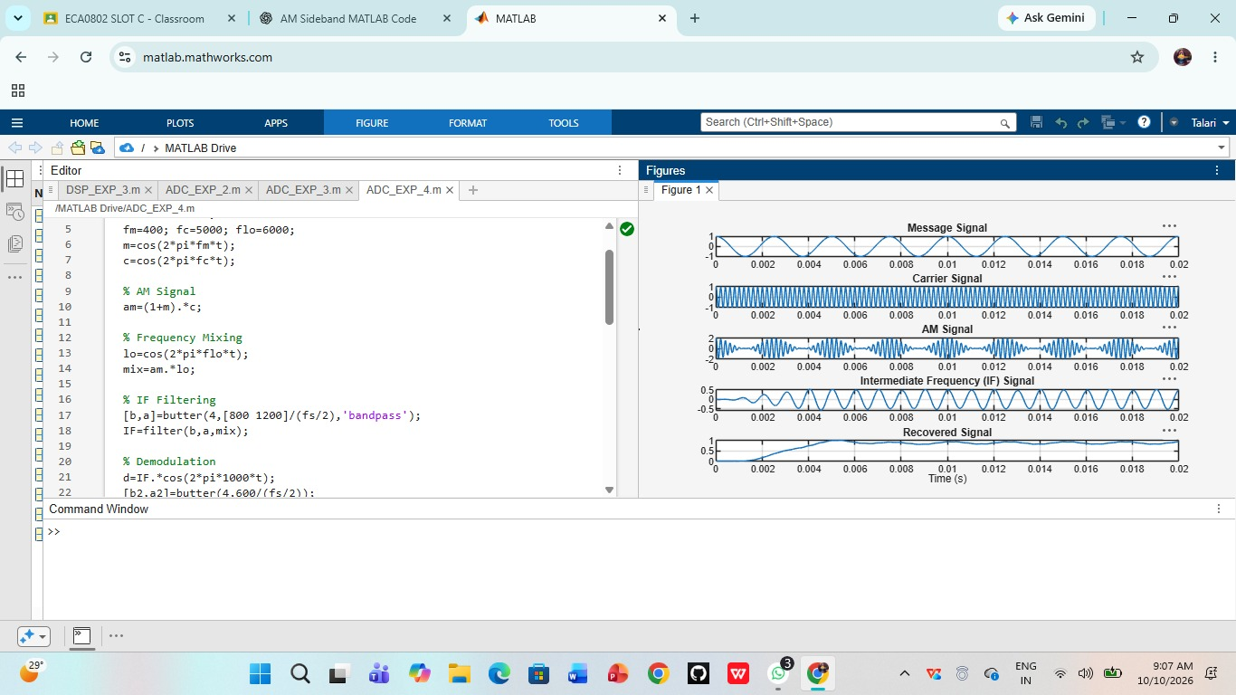

RESULT:
Thus, the operation of a superheterodyne receiver using frequency mixing and filtering was successfully demonstrated using MATLAB.

